Gas Sense  
**Documentation**

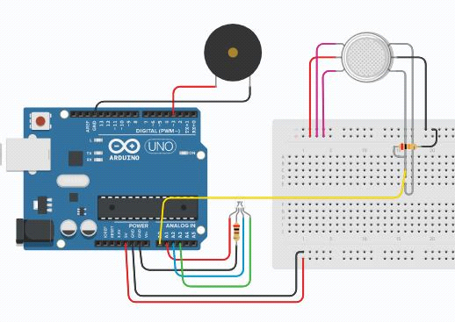

Content

1. Project description . . . . . . . . . . . . . . . . . . . . . . . . . . . . . . . . . . . . . . . . . . . 3

2. Block diagram. . . . . . . . . . . . . . . . . . . . . . . . . . . . . . . . . . . . . . . . . . . . . . .3-4

3. Wiring diagram . . . . . . . . . . . . . . . . . . . . . . . . . . . . . . . . . . . . . . . . . . . . . . .5

4. List of components . . . . . . . . . . . . . . . . . . . . . . . . . . . . . . . . . . . . . . . . . . . 5

5. Functionality description of the source code . . . . . . . . . . . . . . . . 6-7

Description

The main idea of this project is to have an installation in a premises, capable of detecting gas or other pollutants in the air and inform the inhabitants for their presence. The goal is to avoid life-threatening scenarios, which may lead to fatal outcomes.

The project consists of three main components: Arduino board, gas sensor and alarm. When gas or smoke is being detected, chemical reactions in the sensor take place, which alternates the current in the circuit. As a result, the alarm gets activated. In addition to that, RGB LED gets coloured from green to red.

Block diagram

Simplified block diagram of the electrical components

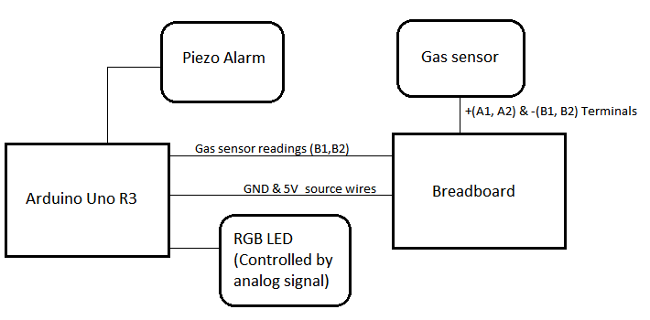

Block diagram of the source code

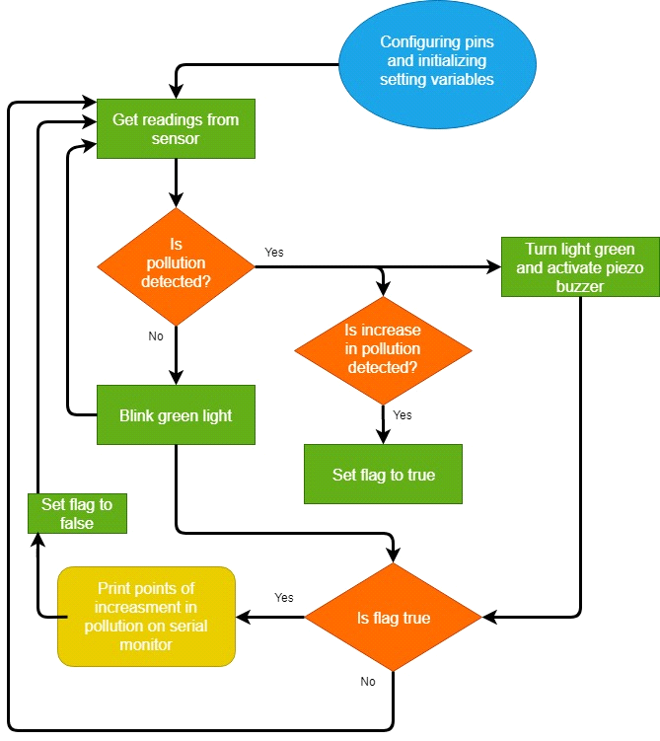

Wiring diagram

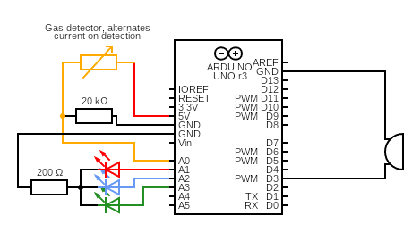

List of components

- Arduino Uno R3  
- Gas detector  
- Piezoelectric buzzer  
- RGB LED  
- 1x 200Ω Resistor  
- 1x 20kΩ Resistor  
- 1x Breadboard  
- 20x Jumper wires

Source code

At the beginning we initialize our constants which will refer to the coresponding pins on the arduino board. The layout is as follows:

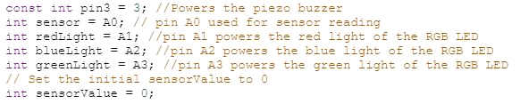

Next, we set up the setting values(calibration values):

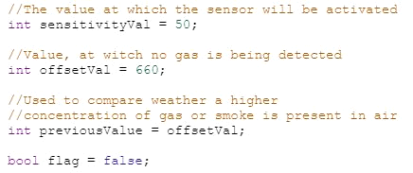

At the *setup* method, we set *pin3* to OUTPUT mode and use *Serial.begin* function so that we can print the sensor values on the serial monitor:

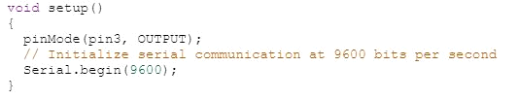

The functionality of the code is in the *loop* method.

Firstly, we set *sensorValue* to the reading from the gas sensor. Then, to monitor the readings from the sensor, we print the values on the serial monitor:

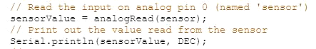

Down the code we have one if-else statement. If *sensorValue* gets higher than its' offset value by *sensetivityVal* points, then the buzzer starts ringing, and the light turns red:

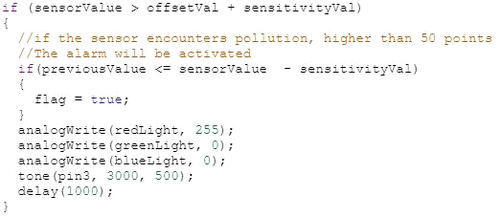

The nested *if* checks wheather *previousValue*, obtained from the initialization or the last loop is higher than usual. if so, flag gets set to true.

Otherwise, the LED blinks with green light:

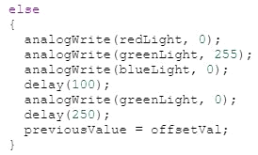

The last if is executed when the air pollution increases. If so, on thr serial monitor are printed the points of increasment.

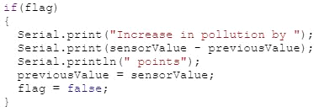

Conclusion

The overall idea of the project is to be into practical use however, without sufficient resources, there is no possible way of realizing the idea to its' full potential.